Name ____________________ | Year 9  Investigation 2  Pythagorean Theorem  Time: 50 mins Marks:____/34 | 

- [10 marks]
1  21  3  4  12  29  15  11  20  10  - Square these numbers | 1  2  64  36  169  25  16  9  144  225  - Square root these numbers

- The hypotenuse of a right triangle is always opposite the right angle. Circle the hypotenuse on the following diagrams. [ 3 marks]

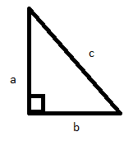 | 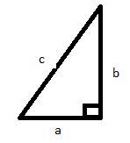 | 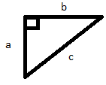

- Find the area of the following squares. [2 marks]
3cm
3cm
- Draw the 4 by 4 square on side a and the 3 by 3 square on side b
  - Record the lengths of each of the sides in the table opposite
  - Find the area of each square and record in the table.
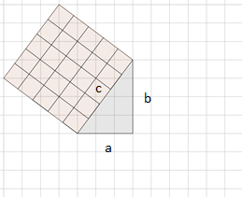
Diagram 1

  - Record the lengths of each of the sides in the table opposite
  - Find the area of each square and record in the table.
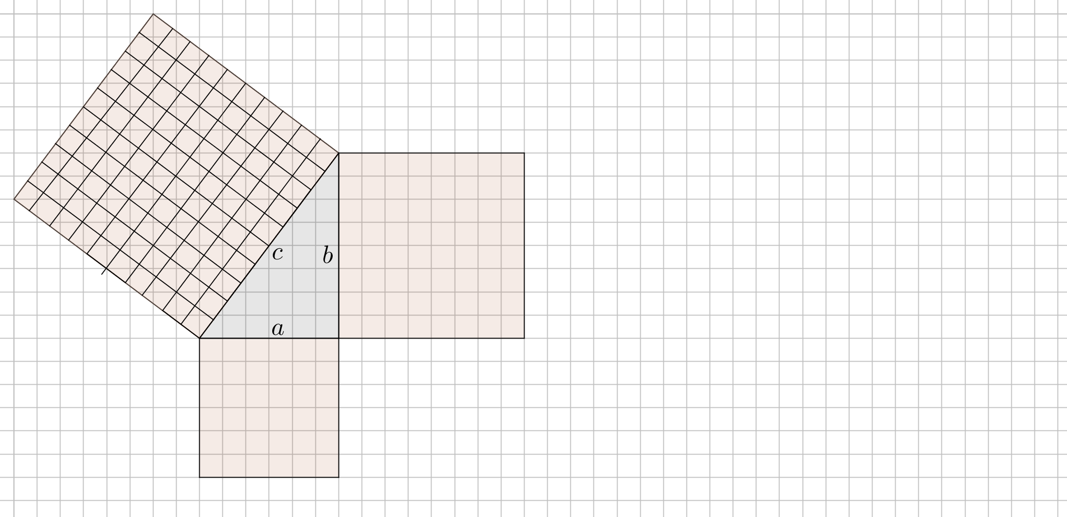
Diagram 2

  - Record the values in the table
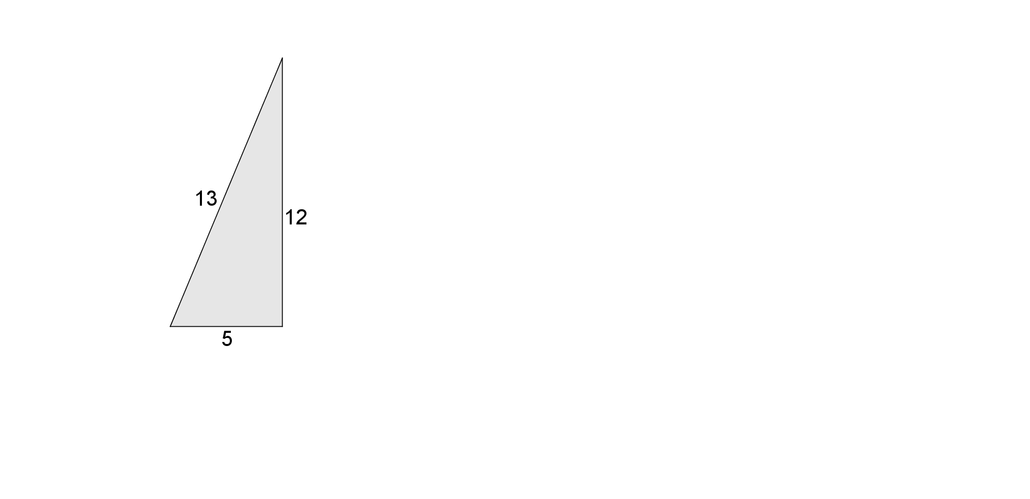
Diagram 3

 | $$a$$ | $$b$$ | $$c$$ | $$a^{2}$$ | $$b^{2}$$ | $$c^{2}$$
Diagram 1 |  |  | 5 |  |  | 25
Diagram 2
Diagram 3
[8 marks]
- Describe the relationship between$a^{2}, b^{2} and c^{2}$. [1 marks]

- Using this relationship fill in the table. [6 marks]
$$a$$ | $$b$$ | $$c$$ | $$a^{2}$$ | $$b^{2}$$ | $$c^{2}$$
9 | 12
30 | 16
21 | 20

- Calculate the unknown sides of the right angle triangles. [4 marks]
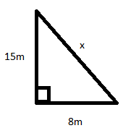 | 